Practice Report
Topic: Research on the relationship between skills and salaries in the Russian labor market in the field of data analytics
Code: Практика.ipynb
The purpose of this project was to study the relationship between different skill groups and salaries in the field of data analytics in the Russian labor market. hh.ru is a monopolistic company in the labor market in Russia, so it was decided to use this particular resource as a source for research.
The following tasks were implemented within the framework of this project:
- Parsing data from a website hh.ru in the field of data analytics
- Data processing and preparation for research
- Identification of the main skill groups and distribution of skills in the dataset by these groups
- Building models
- Interpretation of results
The work was performed based on the article “Skill Requirements across Firms and Labor Markets: Evidence from Job Postings for Professionals” (Deming & Kahn, 2018).
- Parsing data
We used ready-made code to parse data from hh.ru. Two offloads were made - in February and March. Offloads were made for Moscow and St. Petersburg, Leningrad and Moscow regions according to the following codes (professions): 157 (Head of Analytics), 156 (BI analyst, Data Analyst), 164 (Product Analyst), 165 (Data Scientist).
Both uploads were first preprocessed - many tables from the database being created were combined into one common table: tables were alternately attached to the vacancies table via left_join areas, salaries, employers, schedules, experiences, employments, employment_forms, types, departments, insider_interviews, extended.
- Data processing
Then we combined these uploads (with the removal of duplicates) and got the final dataset. It has 3552 observations and 89 columns.
For convenience, the dataset is posted on github at the link: https://github.com/ArtyomYakovlev/practice/raw/main/Data_full.xlsx
The key column for our study is the key_skills column, which lists the key skills that employers themselves indicate when posting a job. The disadvantage of using this column is that not all employers indicate these skills, and some vacancies that are otherwise suitable for research disappear. However, the advantage of this approach is that employers, in a format convenient for us, indicate the most key skills for a particular vacancy, in their opinion. Because job descriptions are often quite long and there are a lot of not-so-important points that would need to be worked through to get the information we need, if we decided to use the nlp model to find key skills in the full job description.
Below is a graph of the frequency of mentioning skills in the key_skills column by vacancy, where the salary is indicated. Python is a bit underestimated here, since sometimes employers don't specify Python directly, but some specific important libraries from there. However, the separation of 2 key skills (SQL, Python) is obvious.
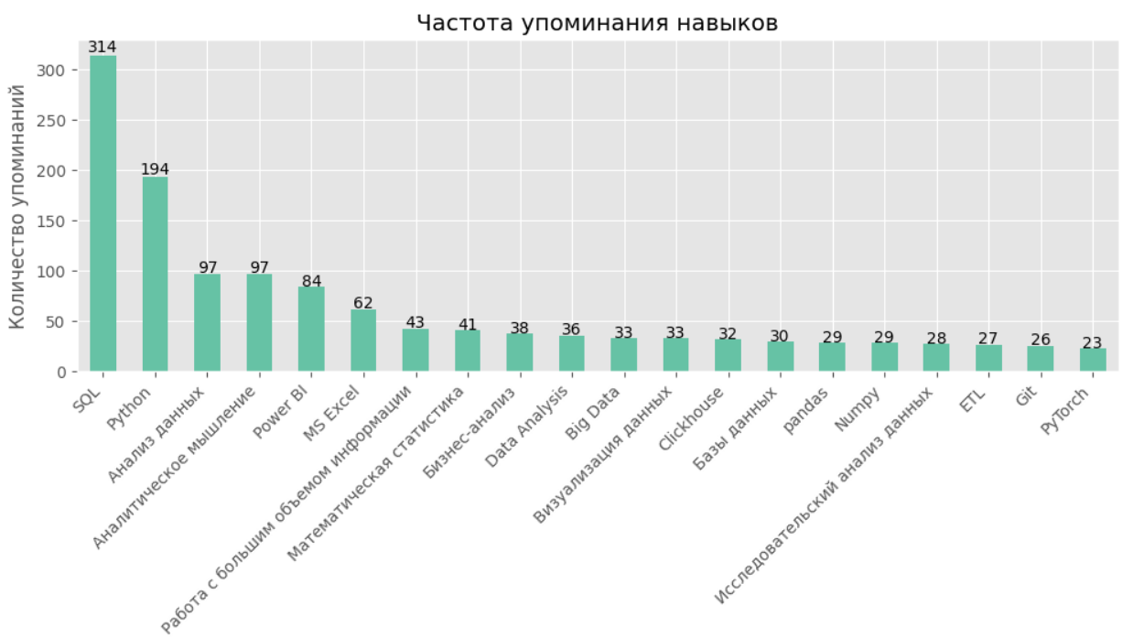
Below is a graph of the frequency of skill mentions in the key_skills column across the dataset, which confirms the conclusions above:
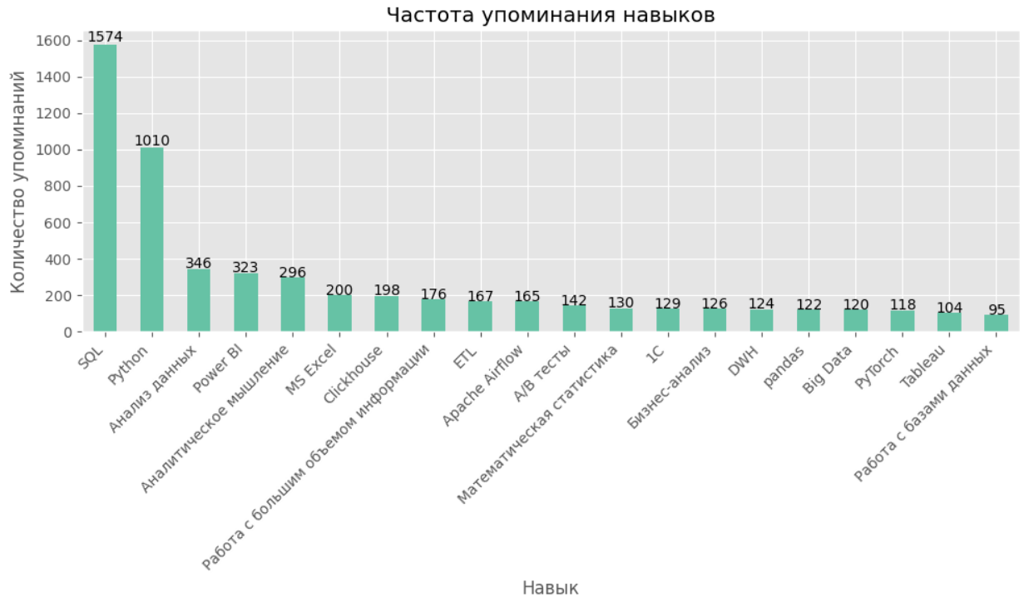
Before building a regression, it is necessary to prepare the data, convert the columns to a format suitable for this, and also work separately with the allocation of skills into groups.
Since the dependent variable is the salary in the vacancy, we leave only observations where at least the lower (from_salary) or upper (to_salary) salary boundaries are indicated. If both boundaries are specified, then we took their average.
Categorical features were also created, such as work experience, type of employment, work schedule, city, as well as company features such as IT accreditation, trust in the company, the size of the company in terms of the number of vacancies, etc.
655 observations remained in the dataset cleared and ready for building a model.
The final list of variables used is shown below:
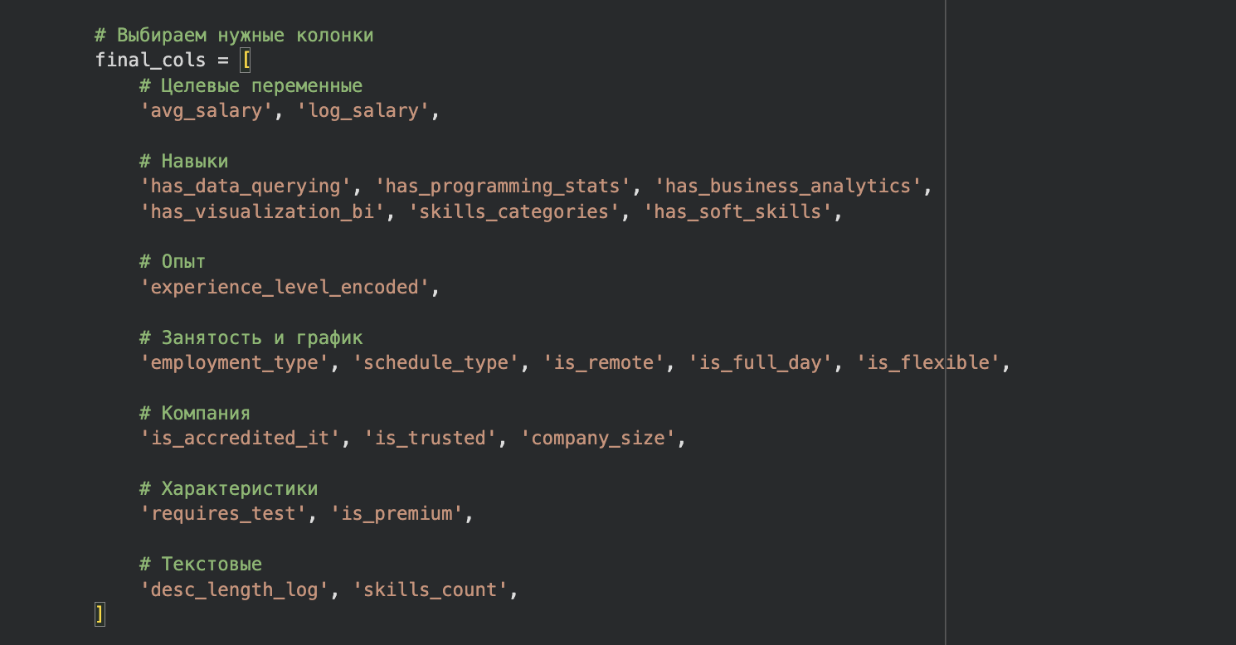
- Identification of the main skill groups
To systematically analyze the skills that influence salary in data analyst vacancies, we first extracted the top 150 most frequent skills from the job descriptions (‘key_skills’). These skills were then manually categorized into five meaningful groups based on their nature and application in the analytics workflow:
- Data Querying – skills related to working with databases, SQL, ETL processes, and data storage.
- Programming & Statistics – programming languages (e.g., Python, R), machine learning libraries, and statistical methods.
- Business Analytics – metrics, A/B testing, product analytics, and business process optimization.
- Visualization & BI – tools for data visualization and business intelligence (e.g., Power BI, Tableau).
- Soft Skills – communication, teamwork, planning, and analytical thinking.
These groups were used to construct binary predictors indicating whether a vacancy mentions at least one skill from a given category.
As a first step, we estimated an OLS regression incorporating the five skill group indicators alongside a set of control variables: experience level, remote work indicator, test requirement, IT accreditation, description length, skills count, and company size. The dependent variable is log-transformed salary to account for the skewed distribution of wages.
The model explains approximately 41.6% of the variance in log-transformed salaries, a substantial improvement over the model without controls.

- Building models
While the aggregated skill groups provide an initial overview, they suffer from a fundamental limitation: heterogeneity within groups. For instance, grouping "Python" and "PyTorch" together in the Programming & Statistics category masks the possibility that advanced machine learning skills may command a different premium than general-purpose programming. Similarly, grouping "Power BI" and "Tableau" in Visualization & BI may obscure differences between specific tools.
To obtain a more granular picture, we constructed a skill matrix where each column represents an individual skill appearing in at least five vacancies. This results in a high-dimensional and sparse design matrix: the number of potential predictors (individual skills) exceeds the number of observations, and the vast majority of entries are zeros, as each vacancy typically lists only a handful of skills. In the literature on text-as-data methods, such matrices are known to pose significant challenges for standard regression techniques (Gentzkow, Kelly, and Taddy 2019).
In such settings, ordinary least squares (OLS) regression is not feasible.
To address these challenges, we employ Lasso (L1-penalized) regression (Tibshirani, 1996). The Lasso estimator solves:

The L1 penalty serves two crucial purposes in our context:
- Feature Selection – By shrinking many coefficients exactly to zero, Lasso selects a parsimonious subset of skills that are most strongly associated with salary, effectively handling the high-dimensionality of the skill matrix.
- Stability in the Presence of Correlated Predictors – Unlike OLS, which produces highly variable estimates when skills are correlated, Lasso provides more stable coefficient paths and tends to select one skill from a group of correlated ones.
Following the standard practice in penalized regression, we select the regularization parameter using the λ.1se rule (Hastie, Tibshirani, and Wainwright, 2015). This choice corresponds to the largest value of λ whose cross-validated error is within one standard error of the minimum. Compared to λ.min, λ.1se yields a more parsimonious model with improved stability and is preferred when the goal is interpretation rather than prediction.
To further assess the stability of our estimates, we run the Lasso with 50 different random seeds, each corresponding to a different training-test split (80% training, 20% testing). A skill is considered stable if it is selected in at least 70% of the runs and its coefficient sign remains consistent (sign stability ≥ 0.8). The reported coefficients represent the average over these 50 runs for skills meeting these stability criteria.
Finally, we include a set of control variables—experience level, employment type, company size, IT accreditation, and other vacancy characteristics—to isolate the partial association of each skill with salary, mitigating omitted variable bias. The full specification thus captures the conditional correlation between skills and salary net of observable confounders.
To assess the partial association between skills and salary, we estimate three progressively more controlled specifications:
- Model 1 (Skills only) – Includes only the skill indicators (binary variables for individual skills) with no controls.
- Model 2 (Skills + Experience) – Adds the key covariate: experience level (experience_level_encoded), the strongest predictor of salary.
- Model 3 (Skills + Full Controls) – Adds all control variables: experience, employment type, work schedule, company characteristics (IT accreditation, company size), vacancy features (test requirement, premium status, description length).
All models are estimated using Lasso with λ.1se selection and 50 random seeds to ensure stability. Coefficients are reported in log points and can be interpreted as approximate percentage changes in salary.

- Interpretation of results
To understand how the association between skills and salary changes as we progressively account for confounding factors, Table below tracks the estimated coefficients for a representative set of skills across the three model specifications.

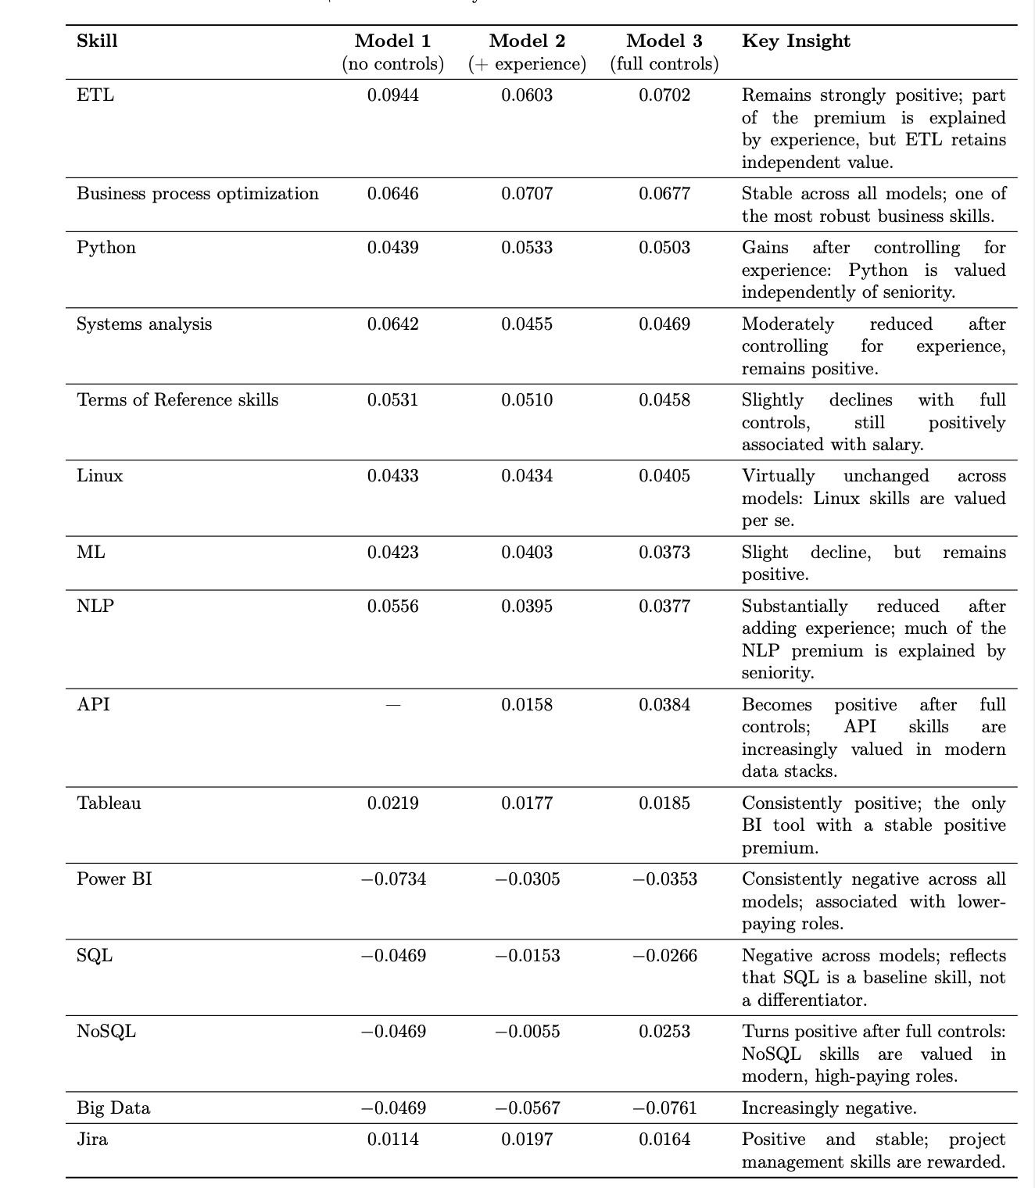
Table 1. Estimation Dynamics Across Models.
Table 1 traces the evolution of skill coefficients across three model specifications. The results reveal which skills retain independent value after controlling for experience and other covariates, and which skills' apparent premiums are largely explained by seniority.

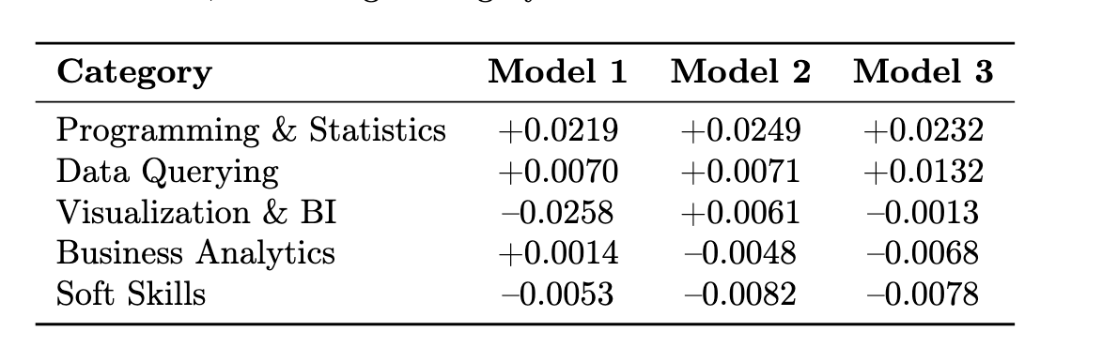Table 2. Average Category Coefficients Across Models
Table 2 summarizes the average coefficient for each skill category across the three model specifications. Skills are included only if they are stable (selection_freq > 0.7) in the respective model. The results show that Programming & Statistics and Data Querying are the only categories with consistently positive average coefficients across all specifications, while Business Analytics and Soft Skills turn negative after controlling for experience and other covariates. Visualization & BI flips from negative in Model 1 to slightly positive in Model 2 before settling near zero in Model 3.
Skill Consolidation and Model Stability
After consolidating synonymous skills (e.g., merging 'ML' and 'Machine Learning', combining various SQL dialects), the number of predictors decreased from approximately 105 to 78. This simplification led to a reduction in the model's explanatory power (R² from 0.197 to 0.054) but substantially improved the stability of coefficient estimates and the interpretability of the results. The cross‑validation plot assumed a clear U‑shape, allowing for a principled selection of the regularization parameter λ.1se, and the selected skills now represent distinct competencies rather than redundant variants of the same underlying capability. This trade‑off between predictive fit and interpretability is a deliberate choice: our goal is to identify stable, interpretable skill–salary associations rather than to maximize predictive accuracy.

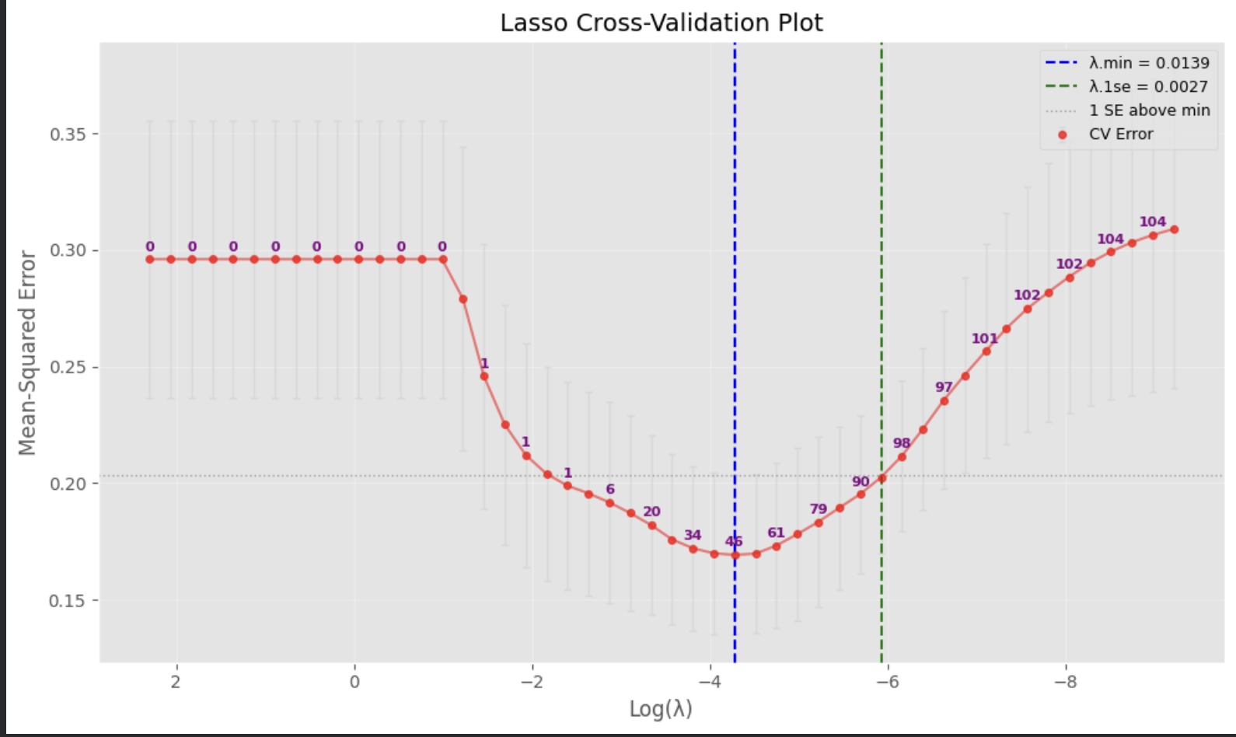

Figure 1. Representative Lasso cross-validation plot. The red dots represent mean cross-validated error at each λ, with error bars indicating ± one standard deviation. The blue vertical line marks λ.min (minimum error), while the green line shows λ.1se (largest λ within one standard error of the minimum). Numbers above the plot indicate the number of non-zero coefficients at each λ value. The clear U‑shape enables a principled choice of the regularization parameter.
For complete replication materials, including all figures, additional stability diagnostics, and the full set of coefficient estimates, please refer to the accompanying Google Colab notebook. The notebook contains the Python implementation of the Lasso models, the skill normalization pipeline, and all visualizations that could not be included in the main text.

References
Deming, D. J., & Kahn, L. B. (2018). Skill Requirements across Firms and Labor Markets: Evidence from Job Postings for Professionals. Journal of Labor Economics, 36(S1), S337–S369.
Gentzkow, M., Kelly, B., & Taddy, M. (2019). Text as Data. Journal of Economic Literature, 57(3), 535–574.
Hastie, T., Tibshirani, R., & Wainwright, M. (2015). Statistical Learning with Sparsity: The Lasso and Generalizations. CRC Press.
Tibshirani, R. (1996). Regression Shrinkage and Selection via the Lasso. Journal of the Royal Statistical Society: Series B, 58(1), 267–288.

